UPDATED PROJECT STRUCTURE
HospitalManagementSystem
│
├── Presentation
│ └── Program.cs/MVC/Angular
│
├── BLL
│ ├── PatientsBLL.cs
│ └── DoctorsBLL.cs
│
├── DAL
│ ├── IPatientManager.cs
│ ├── IDoctorManager.cs
│ ├── PatientManagerADO.cs
│ ├── DoctorManagerADO.cs
│ ├── PatientManagerEF.cs
│ ├── DoctorManagerEF.cs
│
├── Models
│ ├── Doctor.cs
│ ├── Patient.cs
│ ├── Appointment.cs
│
├── Data
│ └── HospitalDbContext.cs
│
└── app.config

Target Architecture Overview

We’ll transform your Hospital Management Console Project into a:
- ✅ Layered Architecture (Clean Separation)
- ✅ ASP.NET Core MVC
- ✅ ASP.NET Core Web API
- ✅ Microservices-ready Structure
- ✅ Scalable Enterprise Architecture
And I’ll also show the architecture visually.

🏥 Target Architecture Overview
We are moving from:
Console App (Monolithic)
To:
MVC App
Web API
Microservices
Using proper Layered Architecture

🧱 WHAT IS LAYERED ARCHITECTURE?
Layered Architecture separates responsibilities into logical layers:
- Presentation Layer
- Application Layer
- Domain Layer
- Infrastructure Layer
- Database Layer
This aligns with:
- SOLID
- DDD
- Clean Architecture
- Enterprise Microservices

🏗 FINAL ENTERPRISE STRUCTURE
We will split into separate applications/projects:
HospitalManagementSolution
│
├── Hospital.Web (ASP.NET Core MVC)
├── Hospital.API (ASP.NET Core Web API)
├── Hospital.DoctorService (Microservice)
├── Hospital.PatientService (Microservice)
│
├── Hospital.Application (Class Library)
├── Hospital.Domain (Class Library)
├── Hospital.Infrastructure (Class Library)
│
└── Hospital.SharedKernel

🔵 1️⃣ DOMAIN LAYER (Core)
📦 Project: Hospital.Domain
This contains:
- Entities
- Enums
- Interfaces
- Value Objects
- Domain Rules
Example:
Doctor.cs
Patient.cs
Appointment.cs
IDoctorRepository.cs
IPatientRepository.cs
⚠️ Domain must NOT depend on any other layer.

🟢 2️⃣ APPLICATION LAYER (Business Logic)
📦 Project: Hospital.Application
Contains:
- DTOs
- Services
- Use Case Logic
- Interface contracts
Example:
DoctorService.cs
PatientService.cs
AddDoctorCommand.cs
GetPatientQuery.cs
Depends on:
Hospital.Domain
But NOT on Infrastructure directly.

🟡 3️⃣ INFRASTRUCTURE LAYER
📦 Project: Hospital.Infrastructure
Contains:
- EF Core DbContext
- ADO.NET implementation
- Repository Implementations
- External integrations
Example:
HospitalDbContext.cs
DoctorRepository.cs
PatientRepository.cs
Depends on:
Hospital.Domain
Hospital.Application

🔴 4️⃣ PRESENTATION LAYER
Now we create separate front-facing applications:

OPTION A — ASP.NET Core MVC
📦 Project: Hospital.Web
Responsibilities:
- Controllers
- Razor Views
- ViewModels
- UI
Flow:
Controller → Application Service → Repository → DB

OPTION B — ASP.NET Core Web API
📦 Project: Hospital.API
Responsibilities:
- REST Endpoints
- Swagger
- JWT Authentication
Example:
GET /api/doctors
POST /api/patients
PUT /api/patients/{id}
DELETE /api/patients/{id}
Used by:
- Angular frontend
- Mobile apps
- External systems

OPTION C — Microservices Architecture
Now we split the system into:

🧩 Doctor Microservice
Project: Hospital.DoctorService
- Own Database
- Own API
- Own DbContext

🧩 Patient Microservice
Project: Hospital.PatientService
- Own Database
- Communicates with DoctorService via API
- REST or RabbitMQ

🧠

HOW EVERYTHING CONNECTS

MVC App Architecture
Browser
↓
Hospital.Web (MVC)
↓
Hospital.Application
↓
Hospital.Infrastructure
↓
SQL Server

Web API Architecture
Client (Angular / Postman)
↓
Hospital.API
↓
Application Layer
↓
Infrastructure Layer
↓
Database

Microservices Architecture
Client
↓
API Gateway
↓
DoctorService → DoctorDB
PatientService → PatientDB
Services communicate via:
- HTTP
- RabbitMQ
- gRPC

🖼 LAYERED ARCHITECTURE DIAGRAM
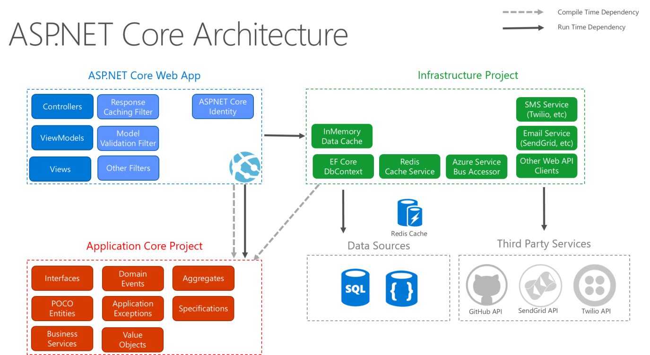
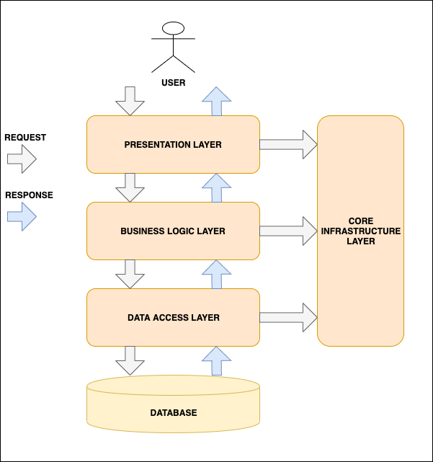
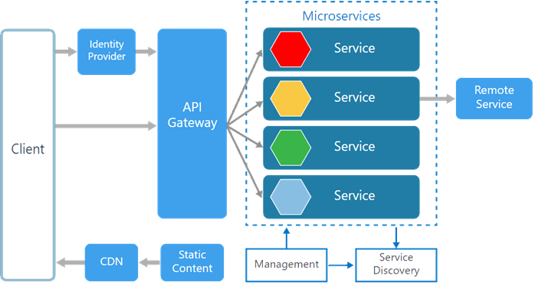
4

📊 CLEAN LAYER VISUAL (Text Version for Classroom)
┌─────────────────────────────┐
│ Presentation Layer │
│ MVC / Web API / Angular │
└───────────────▲──────────────┘
│
┌───────────────┴──────────────┐
│ Application Layer │
│ Services / DTOs / Use Cases │
└───────────────▲──────────────┘
│
┌───────────────┴──────────────┐
│ Domain Layer │
│ Entities / Interfaces / DDD │
└───────────────▲──────────────┘
│
┌───────────────┴──────────────┐
│ Infrastructure Layer │
│ EF Core / ADO.NET / Repo │
└───────────────▲──────────────┘
│
SQL Server

🔥 HOW TO CREATE THIS IN VISUAL STUDIO

Step 1: Create Blank Solution
dotnet new sln -n HospitalManagement

Step 2: Create Class Libraries
dotnet new classlib -n Hospital.Domain
dotnet new classlib -n Hospital.Application
dotnet new classlib -n Hospital.Infrastructure

Step 3: Create MVC
dotnet new mvc -n Hospital.Web

Step 4: Create Web API
dotnet new webapi -n Hospital.API

Step 5: Add Project References
Web → Application
Application → Domain
Infrastructure → Domain
API → Application

